After pulling from <https://github.com/OmniMT/OmniLOOP-CMS.git>, I got the following issues when try to run it in Eclipse:

1. Lack the BasicEntiy.java
2. Pom.xml not up to date, like: lack the dependency of com.twilio.sdk
3. After manually fix the above two issues when deploy to tomcat, got these errors:
   1. Could not load properties; nested exception is java.io.FileNotFoundException: class path resource [${omt.cms.deploy.environment}/com.omt.cms.cust.data.config/postgres.properties]
   2. I once fixed the above error manually, but got other more errors like:

Error creating bean with name 'entityManagerFactory' defined in class path resource [com.omt.cms.cust.data.config/postgres-beans.xml]:

1. I suppose some of the errors may due to not submit all code to keep the git master branch up-to-date. I reckon it would be better to have a Readme file to explain the above and deploy configuration things including database and eclipse environment.

Steps needed to run Compiling, Deploying without errors:

1. Fetch from <https://github.com/OmniMT/OmniLOOP-CMS.git>
2. Modify JDK version to 1.8
3. Add BasicEntity.java to cms-core at com.omt.cms.entity

@MappedSuperclass

public abstract class BaseEntity {

@Id

@GeneratedValue(strategy = GenerationType.AUTO)

@Column(name = "id", updatable = false, nullable = false)

protected Long id;

@Column(name="created_on")

protected Timestamp createdOn;

@Column(name="last_updated")

protected Timestamp lastUpdated;

@Column(name="notes")

protected String notes;

@JsonDeserialize(using=LongToDateJsonDeserializer.class)

@Column(name="valid_until")

protected Timestamp validUntil;

@Column(name="tag_role")

protected String tagRole;

@Column(name="status")

protected Integer status;

@Column(name="total")

private Long total;

@Column(name="active", nullable = true)

private Boolean active = true;

… …

1. Add com.twilio.sdk dependency to cms-master-service

<dependency>

<groupId>com.twilio.sdk</groupId>

<artifactId>twilio-java-sdk</artifactId>

<version>6.3.0</version>

</dependency>

1. Use mvn install -DskipTests to avoid testing :This can be fixed later
2. Eclipse tomcat run add at Open launch configuration:

-Domt.cms.deploy.environment="/dev"

1. [for deploying com-master-admin]:
   1. Add dependency into pom.xml:

<dependency>

<groupId>org.apache.httpcomponents</groupId>

<artifactId>httpcore</artifactId>

<version>4.4</version>

</dependency>

1. File uploading
2. Generate version without testing:

mvn clean install -Domt.cms.deploy.environment="./prod" -Dmaven.test.skip=true

**Reference to**

**[http://websystique.com/spring-security/secure-spring-rest-api-using-oauth2/]**

**For access token things**

Functionality in diagram:

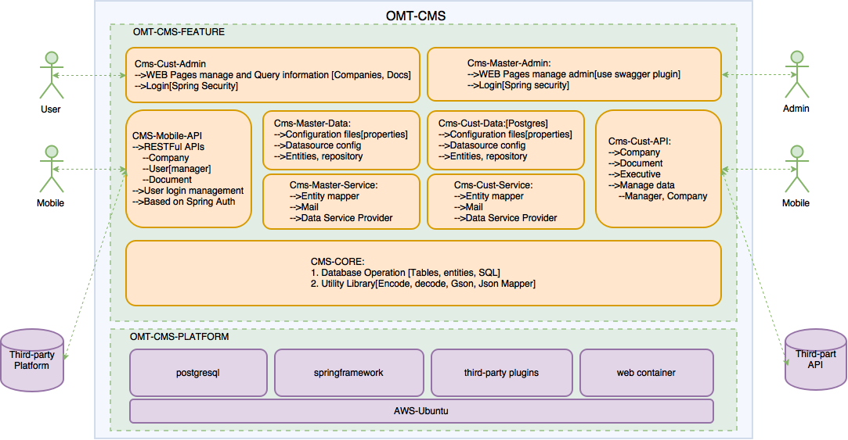

* Tomcat8
  + /usr/share/tomcat8/bin
  + setenv.sh:

root@ubuntu:/usr/share/tomcat8/bin# more setenv.sh

export CATALINA_OPTS="$CATALINA_OPTS -Domt.cms.deploy.environment=prod"

export CATALINA_OPTS="$CATALINA_OPTS -Xms512m"

export CATALINA_OPTS="$CATALINA_OPTS -Xmx8192m"

export CATALINA_OPTS="$CATALINA_OPTS -XX:MaxPermSize=256m"

* + /var/lib/tomcat8/webapps
* Postgresql:
  + Install

>$ sudo apt-get update && sudo apt-get upgrade

>$ sudo apt-get install postgresql postgresql-contrib

* + Path on mac: /Users/tonyliu/PostgreSQL/pg95
    - Success. You can now start the database server using:

/Users/tonyliu/PostgreSQL/pg95/bin/pg_ctl -D /Users/tonyliu/PostgreSQL/data/pg95 -l logfile start

* + Log file positon: /var/log/postgresql
  + Configuration file: /etc/postgresql/9.5/main/
  + Start/Restart: sudo service postgresql start/restart
  + sudo -u postgres psql omtcms

REF:

<http://askubuntu.com/questions/423165/remotely-access-postgresql-database>

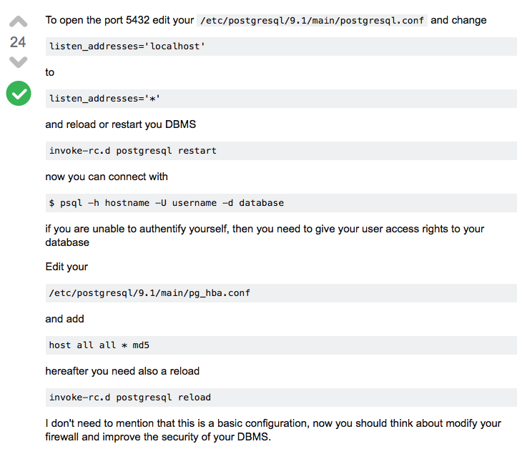

<http://www.thegeekstuff.com/2014/02/enable-remote-postgresql-connection/?utm_source=tuicool>

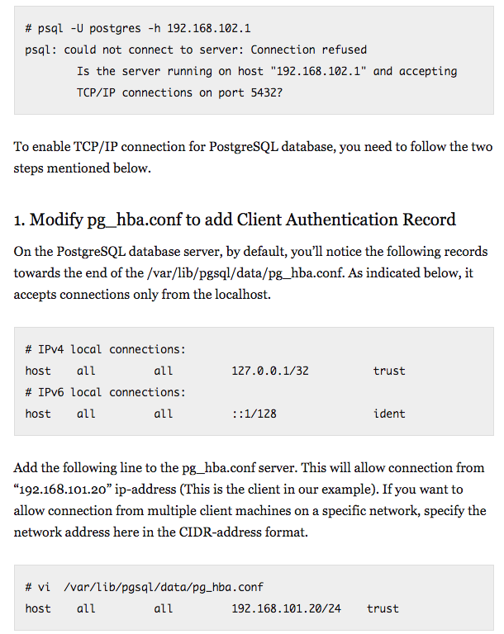

Reset password for Django + Sqlite

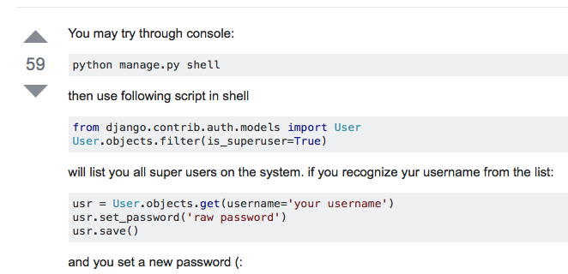

Django + Python + Eclipse

/Users/tonyliu/Documents/pythonNew/djangoTest/testjango

>$ python manage.py runserver

1159 cd pythonNew/

1160 l

1161 mkdir djangoTest

1162 l

1163 cd djangoTest/

1164 l

1165 l

1166 djongo

1167 django-admin startproject testjango

1168 l

1169 cd testjango/

1170 l

1171 python manage.py help

1172 python manage.py startapp

1173 python manage.py startapp homepage

1174 l

1175 cd homepage/

1176 l

1177 ..

1178 l

1179 mkdir templates

1180 mkdir static

1181 l

1182 cd testjango/

1183 l

1184 vi settings.py

1185 l

1186 ..

1187 l

1188 python manage.py runserver

536 django-admin createsuperuser

537 django-admin createsuperuser

538 django-admin help

504 cd Documents/

505 l

506 cd pythonNew/

507 l

508 cd djangoTest/

509 l

510 cd testjango/

511 l

512 python manage.py makemirgrations

513 python manage.py makemigrations

514 python manage.py migrate

515 python manage.py createsuperuser

516 pwd

517 ...

518 l

519 cd djangoTest/

520 l

521 cd testjango/

522 l

523 cd homepage/

524 l

525 cd ../templates/

526 ls

527 touch home.html

528 cd ..

529 **python manage.py makemigrations**

530 **python manage.py migrate**

531 ls

532 cd homepage/

533 ls

534 touch urls.py

535 python manage.py collectstatic

536 ls

537 cd ..

538 ls

539 python manage.py collectstatic

540 ls

1. **package** com.omt.cms.cust.service.impl; DocumentLinksMediaServiceImpl
2. **package** com.omt.cms.master.service.impl;

CompanyServiceImpl